HARSHIKA SOFAT – GITHUB ACTIONS TASK ( SHELL FINAL CASE STUDY )

ORIGINAL JAVA CODE :

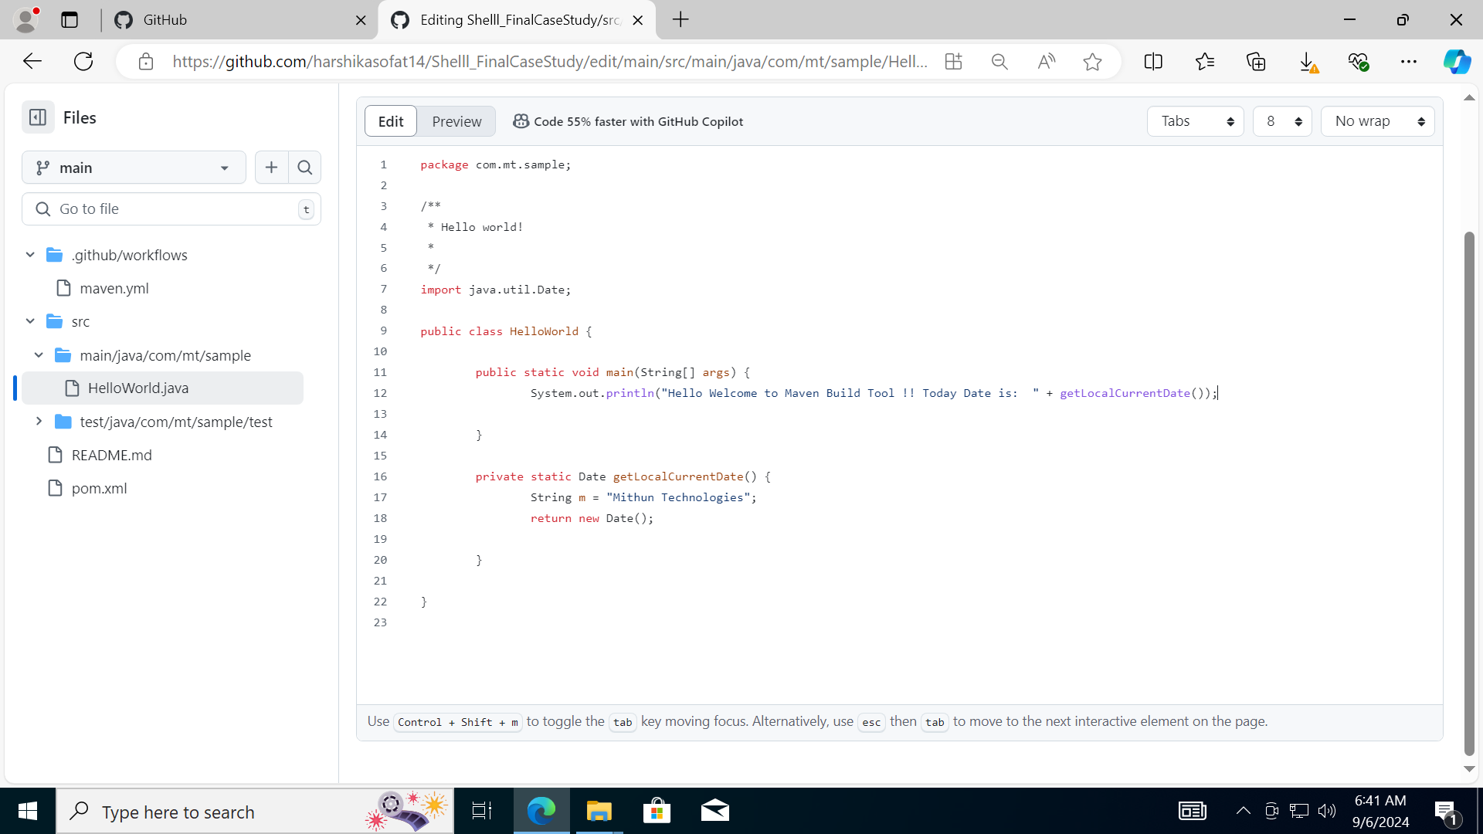

UPDATED JAVA CODE:

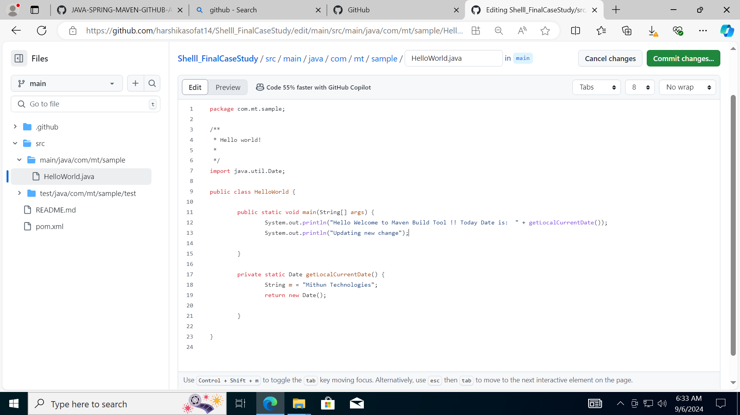

BUILD WORKED

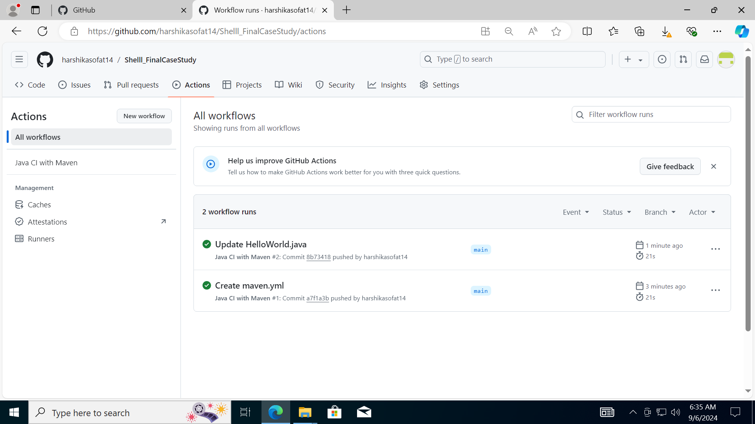

MAVEN.YML FILE

